**Installation Guide/User Manual**

**Smart Solar Siting**

**March 12th, 2018**

**Release 1.0**

**INSTALLATION**

* In order to install the application, get the APKs from the Github Repository on the master branch: <https://github.com/chshsmit/Smart_Solar_Siting>
* Once the APKs are downloaded to your computer, you can build the gradle file on your personal Android device. This is easily done using Android Studio, and connecting your Android device through a USB cable.

**USER MANUAL**

1. When the application first starts it will make sure you have all the necessary permissions in order for the app to run such as location, camera, and internet access
2. On the main screen there is a camera view that will display the solar path across an entire year.

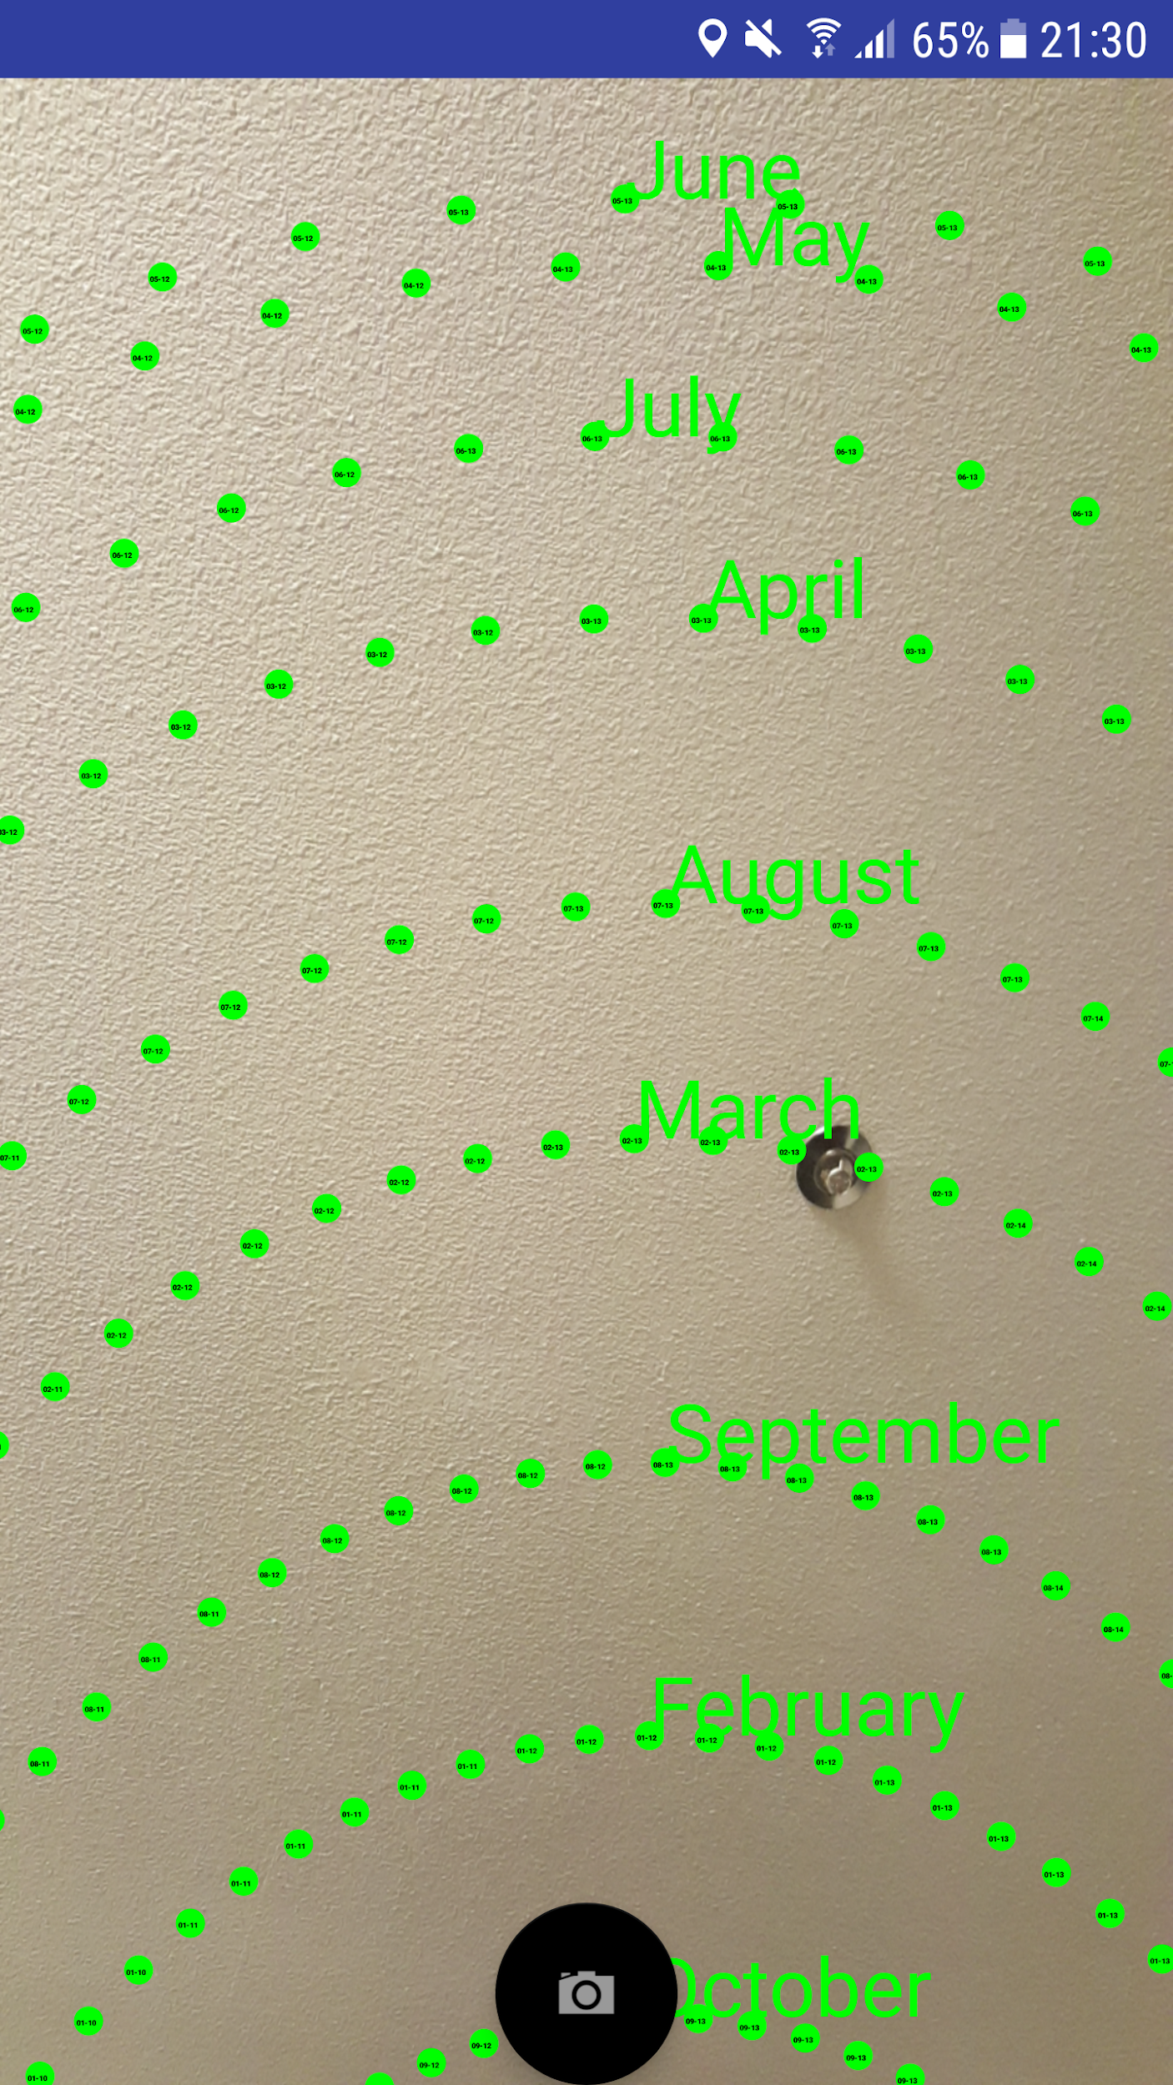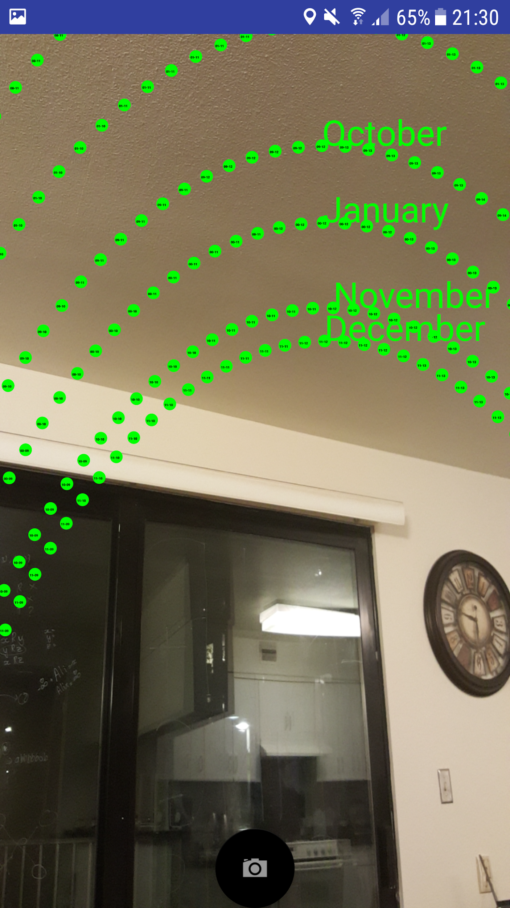

1. In order to perform a site survey you will take a picture pointing towards the solar path which will get the information needed to calculate the amount of power generated for that spot.
2. Once you are ready to take a picture, press the capture button on the bottom of the screen in order to confirm the view you want.
3. After the picture is taken, the application will take you to a new activity where you will be given the option to colour in obstacles and obstructions between the Android device and the sky such as trees and buildings on the picture. You can then click the green checkbox to carry out the calculations, or the red trash can to delete the picture and start over, at which point you will be taken back to the camera activity.

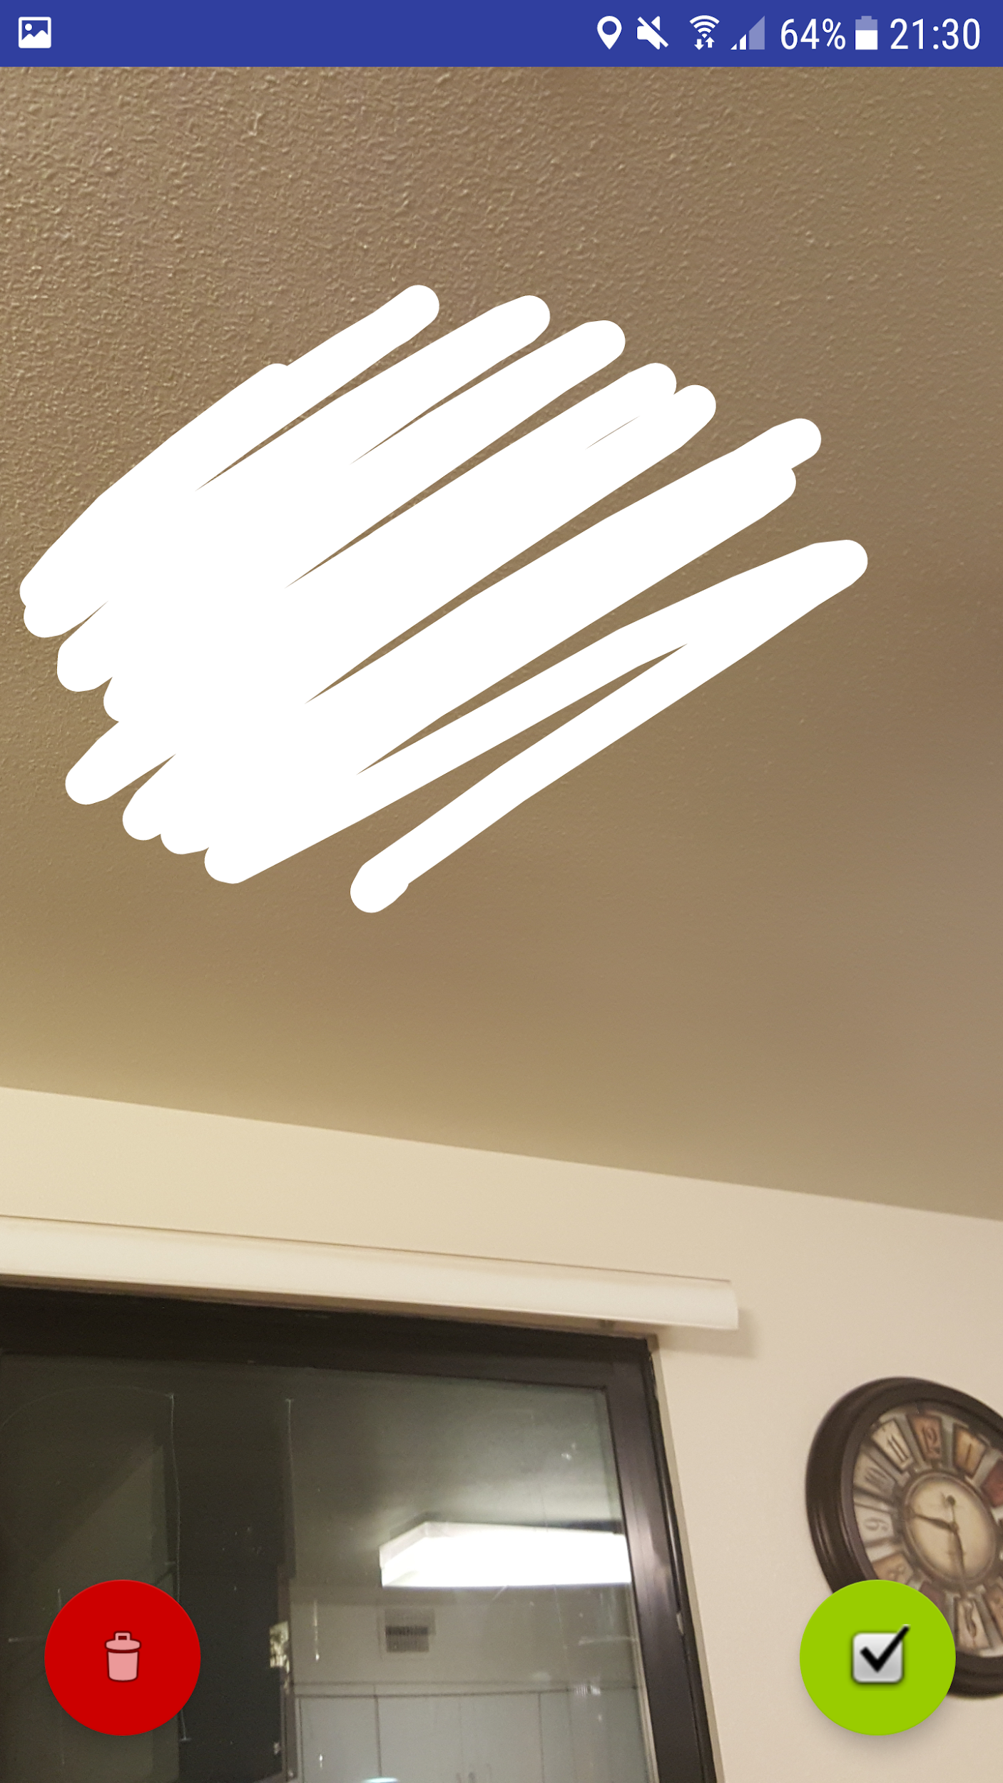

1. After the picture is confirmed, the application will take you to a new activity that will first take a few seconds to load while it is analysing the data, and then display the total amount of power that each month will be able to generate based on what is visible in the picture, as well as the total annual calculation.

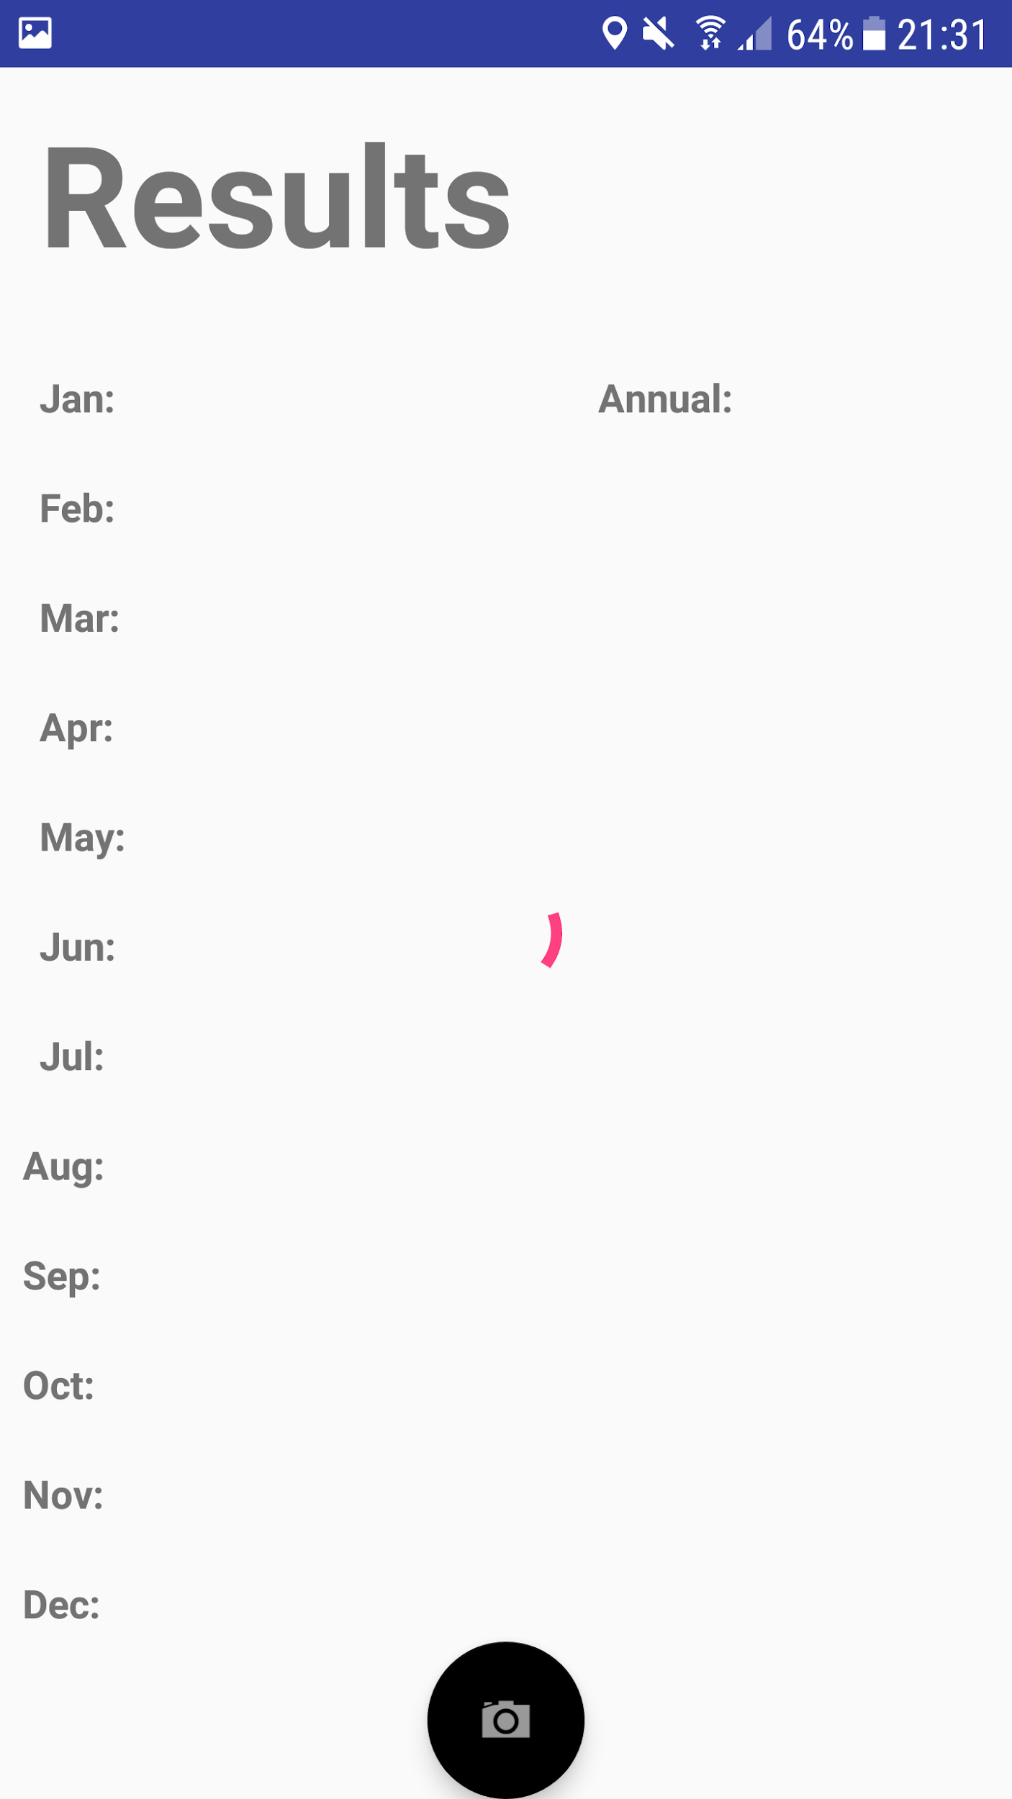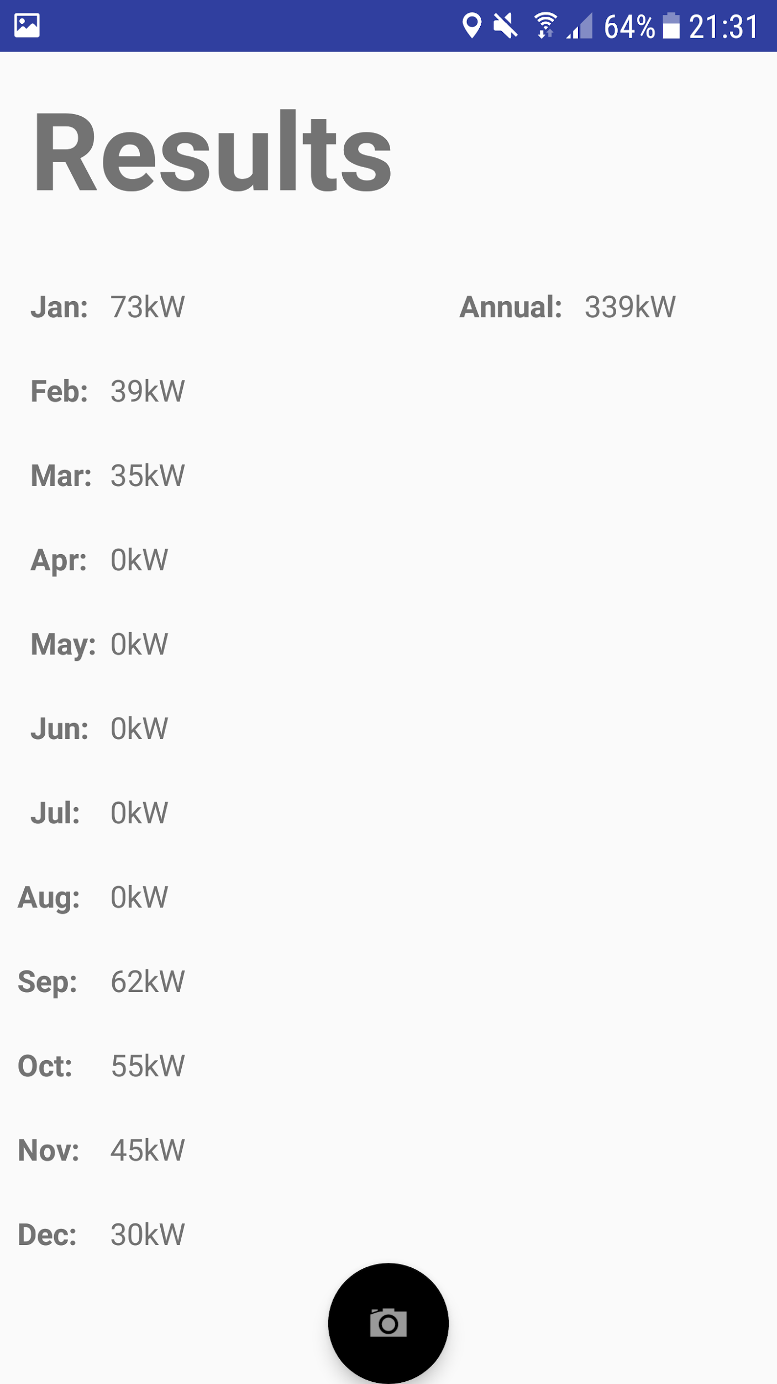

1. To go back to the main camera screen and perform another site survey, either press the back button on the bottom of the device or swipe right to return to the main camera screen.